**EXERCISE -** 4

**JAVA ARRAYS**

**Aim:** Write a java program to read and arrange values in descending order (use scanner class).

**File name:** Decending.java

**Program:**

**//IMPLEMENTING BUBBLE SORT**

**import java.lang.*;**

**import java.util.*;**

**class Decending{**

**public static void main(String args[]){**

**int n;**

**Scanner s=new Scanner(System.in);**

**System.out.print("Enter size of array: ");**

**n = s.nextInt();**

**int[] a = new int[n];**

**System.out.println("Enter the elements in the list");**

**for(int i = 0 ; i < n ; i++){**

**System.out.print("a["+i+"] = ");**

**a[i] = s.nextInt();**

**}**

**for(int i = 0 ; i < n ; i++){**

**for(int j = 0 ; j < n-i-1 ; j++){**

**if(a[j]<a[j+1]){**

**a[j] = a[j] + a[j+1];**

**a[j+1] = a[j] - a[j+1];**

**a[j] = a[j] - a[j+1];**

**}**

**}**

**}**

**System.out.println("Elements in list in Decending order:");**

**for(int i = 0 ; i < n ; i++){**

**System.out.print(a[i]+" | ");**

**}**

**}**

**}**

**Output:**

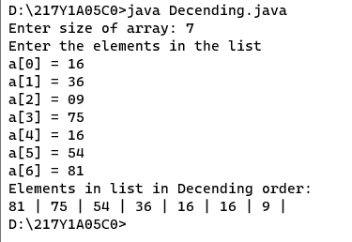

**Aim:** Write a java program to perform matrix addition.

**File name:** MatrixAdd.java

**Program:**

**//Simple Matrix multiplication**

**//if (p == m && q == n)**

**import java.lang.*;**

**import java.util.*;**

**class MatrixAdd{**

**public static void main(String args[]){**

**int n,m,p,q;**

**Scanner s=new Scanner(System.in);**

**System.out.print("Enter Dimentions of first matrix:");**

**n = s.nextInt();**

**m = s.nextInt();**

**int a[][] = new int[n][m];**

**System.out.println("Enter Elements of first matrix: ");**

**for(int i = 0 ; i < n ; i++){**

**for(int j = 0 ; j < m ; j++){**

**a[i][j] = s.nextInt();**

**}**

**}**

**System.out.print("Enter Dimentions of second matrix:");**

**p = s.nextInt();**

**q = s.nextInt();**

**if(p==n && q==m){**

**int b[][] = new int[p][q];**

**System.out.println("Enter Elements of second matrix: ");**

**for(int i = 0 ; i < n ; i++){**

**for(int j = 0 ; j < m ; j++){**

**b[i][j] = s.nextInt();**

**}**

**}**

**int c[][] = new int[n][m];**

**System.out.println("Resultant matrix after additon: ");**

**for(int i = 0 ; i < n ; i++){**

**for(int j = 0 ; j < m ; j++){**

**c[i][j] = a[i][j]+b[i][j];**

**System.out.print(c[i][j]+" ");**

**}**

**System.out.println("");**

**}**

**}**

**else{**

**System.out.println("Matrices of given dimensions are incompatible for Addition!");**

**}**

**}**

**}**

**Output:**

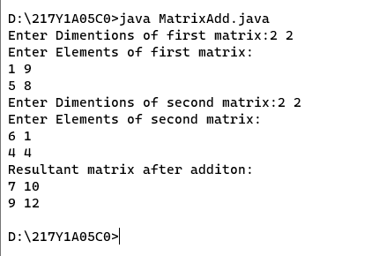

**Aim:** Write a java program to perform matrix multiplication.

**File name:** MatrixMul.java

**Program:**

**//Simple Matrix multiplication**

**//if (p == m && q == n)**

**import java.lang.*;**

**import java.util.*;**

**class MatrixMul{**

**public static void main(String args[]){**

**int n,m,p,q;**

**Scanner s=new Scanner(System.in);**

**System.out.print("Enter Dimentions of first matrix:");**

**n = s.nextInt();**

**m = s.nextInt();**

**int a[][] = new int[n][m];**

**System.out.println("Enter Elements of first matrix: ");**

**for(int i = 0 ; i < n ; i++){**

**for(int j = 0 ; j < m ; j++){**

**a[i][j] = s.nextInt();**

**}**

**}**

**System.out.print("Enter Dimentions of second matrix:");**

**p = s.nextInt();**

**q = s.nextInt();**

**if( m==p ){**

**int b[][] = new int[p][q];**

**System.out.println("Enter Elements of second matrix: ");**

**for(int i = 0 ; i < p ; i++){**

**for(int j = 0 ; j < q ; j++){**

**b[i][j] = s.nextInt();**

**}**

**}**

**int c[][] = new int[n][m];**

**System.out.println("Resultant matrix after multiplication: ");**

**for(int i = 0 ; i < n ; i++){**

**for(int j = 0 ; j < q ; j++){**

**for(int k = 0 ; k < m ; k++){**

**c[i][j] += a[i][k]*b[k][j];**

**}**

**System.out.print(c[i][j]+" ");**

**}**

**System.out.println("");**

**}**

**}**

**else{**

**System.out.println("Matrices of given dimensions are incompatible for Multiplication!");**

**}**

**}**

**}**

**Output:**

